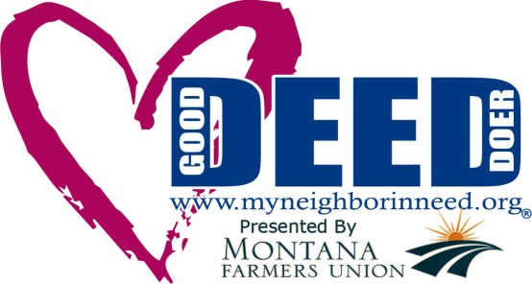
Date: March 24, 2014 Contact: Dave Snuggs
Press Release 406-231-8690

www.myneighborinneed.org
Celebrates Two-Year Anniversary

www.myneighborineed.org a unique website that was created by Great Falls resident, Dave Snuggs, and launched back in the spring of 2012, has celebrated its two-year anniversary.

“This is a day to celebrate! Today we celebrate kindness! Today we celebrate the generosity of strangers! And today, we once again demonstrate that it does not take a lot to do a lot,” Snuggs said. “What started out as the simple idea of anonymous giving has grown into a movement encompassing other social services needed by members of the community including www.mystudentinneed.org, the Pet Food Pantry and the Give What You Can Community Thrift Store.”

My Neighbor in Need, a non-profit organization, based in Great Falls Montana, has satellite projects in Teton County (operated in partnership with Neighbors Helping Neighbors) and Lewistown, Montana. In addition, My Neighbor in Need is available in Southern Wisconsin through a partnership with Saint Vincent De Paul. My Neighbor in Need provides citizens a way to ask for help from their community and a way for the community to give back.

In two years, My Neighbor in Need has received over 3,400 requests for help and has fulfilled over 2,300 needs with almost 2,100 fulfilled in Cascade County Montana alone. “Although the website has been instrumental in connecting those in need with those willing to help, without the community embracing the concept My Neighbor in Need would simply be a website. I want to thank our sponsors, community partners, volunteers and most of all the caring individuals and organizations who every day wake up and make the choice to help a neighbors in need. Their compassion and dedication is without measure,” Snuggs said.

www.myneighborinneed.org developed by Tom Penwell of Tom’s Web Designs, allows for anyone to ask for help with a specific need whether the need is for themselves or for someone else in their community by simply going to the website and completing the Request a Need form and clicking submit. If a person does not have access to the website to complete the form, they may call (406) 453-HELP and the form can be completed over the phone. In addition, the Request for a Need form can mailed to: My Neighbor in Need, PO Box 1788 Great Falls, MT 59403.

Once the form is submitted, it is retrieved through a private back-office computer system accessed only by our staff or “Good Deed Doers.” Good Deed Doers are trained volunteers who then review the submitted form, contact the person requesting help, and through a series of questions, complete the verification process. Once the need has been verified and if approved, the need instantly goes LIVE on the website so anyone may review the request and offer assistance by fulfilling the need. Donors have come from all over the world including Afghanistan, Canada and recently, Japan.

-30-

